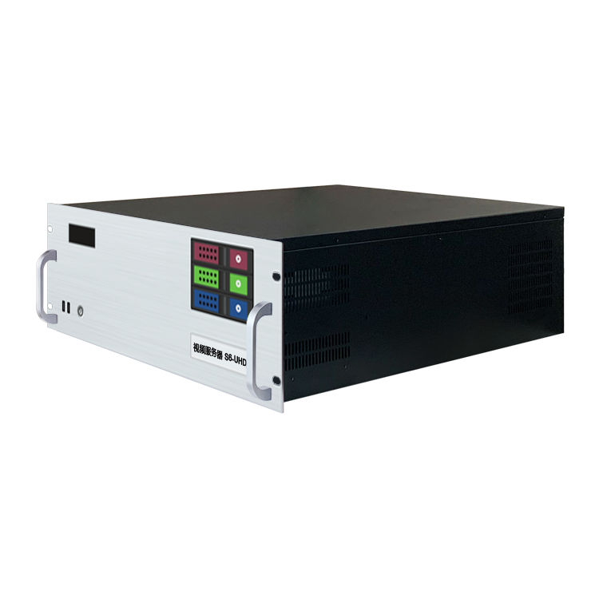
Specification Document
Video Playback Control Server
S6-UHD

Revision History
Release version | Release date | Release notes
V1.0 | 2021-08-31 | • Initial release
V1.1 | 2022-06-15 | • Update Power Supply/Graphics Card/VGA/COM Interface
V1.2 | 2022-09-06 | • Update Appearance Specifications/System Introduction
V1.3 | 2023-05-22 | • Added HDMI monitor port.  • Added DVI monitor port.  • Added a T1000 graphics card for display purposes.  • Changed the playback control system to the windowed version.

Product Introduction
The S6-UHD Video Server is a multimedia integrated playback control server designed for large-scale LED playback control applications in multimedia exhibition halls, banquet halls, live performances, and other scenarios. It combines the signal processing capabilities of traditional multi-screen splicing processors with the media broadcasting functions and lighting arrangement control capabilities of professional stage performances. It not only delivers high-quality, high-resolution point-to-point displays but also enables a wide range of creative display possibilities. The S6-UHD Video Server is equipped with professional LED playback control software, providing users with convenient scene management and a professional LED human-machine interaction interface. It is suitable for performing arts, exhibitions, large-scale buildings, and various creative display applications.

Certification
CCC, CE, Rohs

If the product does not have the relevant certifications required by the destination country or region, please contact RuiZhong Technology immediately for confirmation or handling. Otherwise, if it causes any legal risks, the customer will be responsible or RuiZhong Technology reserves the right to seek compensation.

Product Features
• Single output port with a maximum load width of 4096Px and a maximum height of 2160Px, customizable within the range of 8.84 million Px.
• Overall load capacity: Single screen up to a maximum width of 16384Px and a maximum height of 8640Px, customizable within the range of 35.39 million Px, with a total load capacity of up to 35.39 million Px.
• Hardware decoding capability: 1 channel of 8K hardware decoding or 6 channels of 4K hardware decoding, supporting multiple channels of 2K hardware decoding.
• Video input: Optional 4K/2K input.
• Number of inputs: 1-4 channels of HDMI/DVI/SDI optional.
• Supports multiple signal inputs such as HDMI/DVI/SDI and optional 2K/4K custom capture card.
• Supports control and playback via tablet-based control.
• Supports TCP/UDP protocol for network commands.
• Supports arbitrary rotation of images, suitable for various creative display applications.
• LTC timecode synchronization.
• 650W server power supply.
• Supports 3D mapping.
• Built-in universal decoder capable of decoding common and professional video formats such as HAP, DXV, HEVC, etc.

Product Dimensions
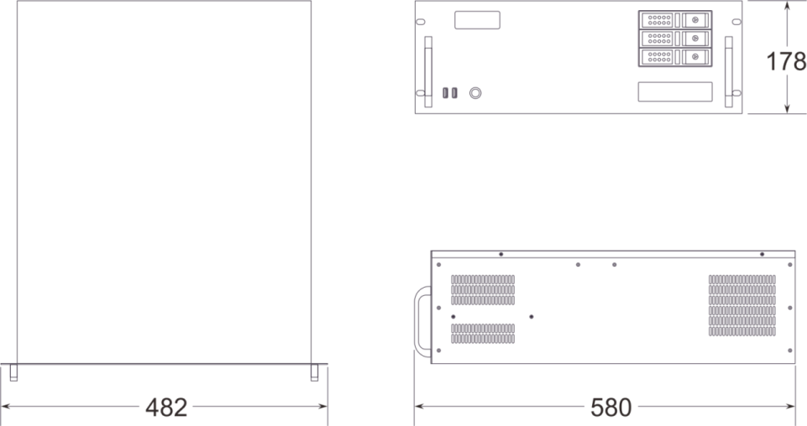

Product Appearance
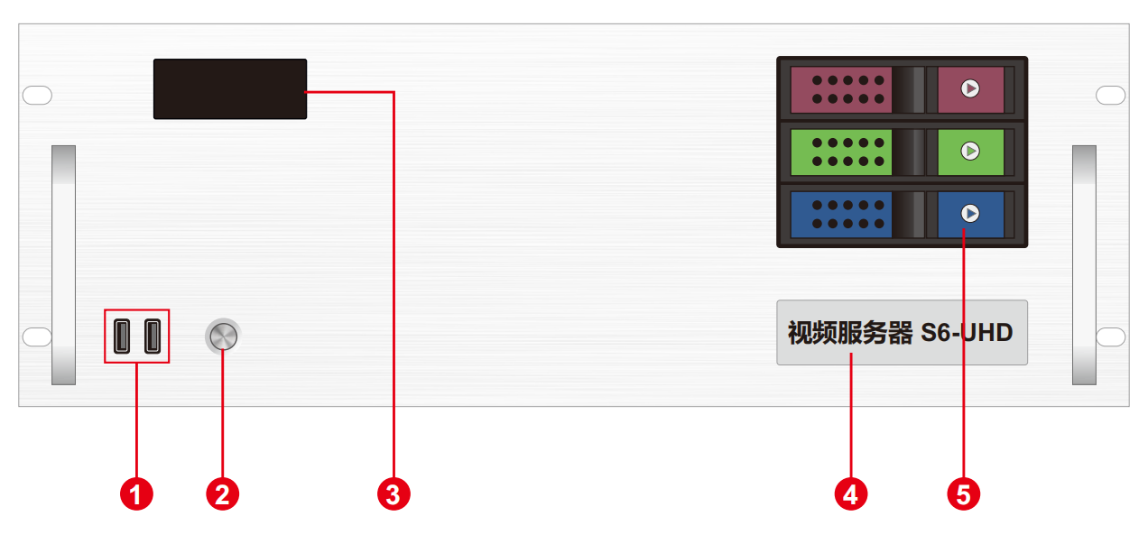

Front Panel
Index | Interface | Number | Description
1 | USB | 1 | • Type-A USB3.0×2  • Connectable to mouse and keyboard.
2 | Power switch button | 1 | • Button for power switch.
3 | Temperature control display screen | 1 | • Display server runtime, temperature, cooling fan status, and abnormal alarms.
4 | Label | 1 | • Server model and name identification.
5 | Front-mounted hard drive enclosure | 3 | • Supports installation of 3.5-inch and 2.5-inch SATA interface hard drives.

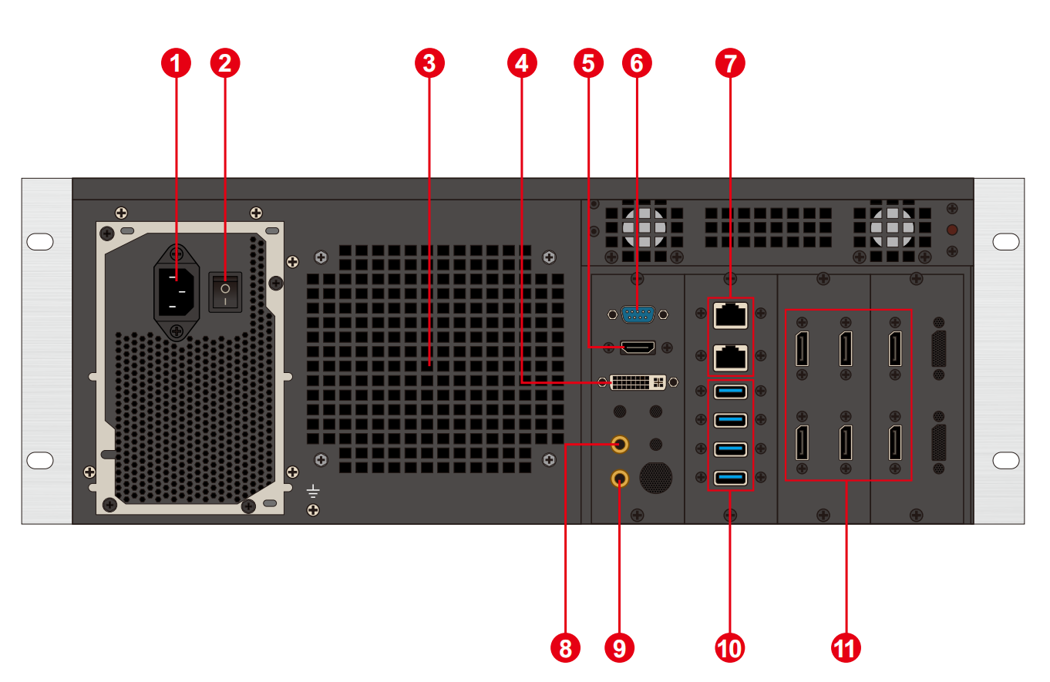
Back Panel
Index | Interface | Number | Description
1 | Power input | 1 | • Power input  • 110V-240V 50/60Hz  • AC power
2 | AC switch | 1 | • Power main switch
3 | Ventilation port | 1 | • CPU liquid cooling fan vent
4 | DVI output | 1 | • Connect DVI monitor  • Used for operating and editing playback control software
5 | HDMI output | 1 | • Connect HDMI monitor  • Used for operating and editing playback control software
6 | COM port | 1 | • COM interface  • Connectable to RS232/485 protocol serial devices
7 | Ethernet port | 2 | • 1GB RJ45 port×1  • 5GB RJ45 port×1
8 | Audio output | 1 | • 3.5mm standard audio output port
9 | Microphone | 1 | • 3.5mm standard audio output port  • Connectable to microphone input audio  • Accepts audio timecode
10 | USB | 4 | • Type-A USB3.0 * 4  • Connectable to mouse, keyboard, USB flash drive, external hard drive, wireless network card, etc.
11 | DP1.4 | 6 | • Connect to a monitor for displaying software editing interface  • Connect to a sending card or display screen for outputting images  • Maximum output: 4096*2160@60Hz

Device Hardware/Software
Hardware Specifications
CPU | Intel Xeon W-2155B @ 3.30GHz, 10 Cores, 20 Threads, Turbo Boost up to 4.5GHz
Memory | 32GB DDR4 RECC
Storage | M.2 1024GB NVMe, supports hot-swappable hard drive installation
Output Graphics Card | AMD RADEON PRO W6800 Professional Graphics Card
Control Graphics Card | NVIDIA T1000 4GB Professional Graphics Card
Power supply | Great Wall 650W power supply
Chassis | 4U hot-swappable chassis
Cooler | Water cooling (CPU), air cooling (GPU)
Software
Operating System | Windows 10 Enterprise Edition | Playback Control System | LED Playback Control System (Windowed Version)
Supply
Input Power | 110-220V AC ~ 50Hz
Maximum Power | 650W

Device Specifications
Electrical Specifications | Input power: 110-240V~ 6A 50/60Hz; Maximum power: 650W
Installation Specifications | 4U rack-mount installation (considering on-site conditions)
Dimension Specifications | 580mm (Length) × 482mm (Width) × 178mm (Height)
Operating Environment | Temperature: 5-35°C (40°-95°F); Humidity: 5%-95% (non-condensing)
Storage Environment | -10°C to +60°C; 0%RH to 95%RH (non-condensing)
Packaging Dimensions | 678mm (Length) × 548mm (Width) × 265mm (Height)
Accessories | Power cord * 1, Ethernet cable * 1, Inspection report * 1, Test report * 1, Certificate of compliance * 1, Packing list * 1, Mouse and keyboard set * 1, Wireless network card * 1, DP cable *6, HDMI cable * 1, Activation label * 1 (to be affixed on the front panel of the chassis)

Media Type
Media types | Media formats
Video | mp4, avi, mkv, flv, mov, wmv, mpeg, mpg, m4v, webm, HAP
Audio | mp3, aac, flac, amr, ape, wav, wma
Image | jpg, jpeg, bmp, png, gif, ico
Text | txt
Streaming media | ndi, http, rtsp, rtp, rtcp, rtmp, mms, hls
Webpage | Supports access to any web page.
Office documents | PPT (1080P)
Description
说明：

Recommended video encoding formats:
• For videos with resolutions of 4K and above, up to 8K, and with width not exceeding 8192 and height not exceeding 4320, it is recommended to use H.265 (HEVC) or VP9 encoding.
• For videos with resolutions up to 4K, it is recommended to use H.264 (AVC) encoding.
• For videos with resolutions higher than 8K, up to width of 15360 and height of 7680, it is recommended to use HAP encoding.

To achieve the best performance and video quality, the recommended video bitrates are as follows:
Resolution | 24-30 fps（Standard Videos） | 48-60 fps（High Frame Rate Videos）
4320P（8K） | 70-100Mbps | 100-140Mbps
2160P（4K） | 35-45Mbps | 55-70Mbps
1080P（2K） | 10Mbps | 16Mbps
*The above are recommended video bitrates for SDR (Standard Dynamic Range) sources.

Optional Configurations
The product types in the optional configurations need to be purchased separately by placing individual orders.
Item/Model | Specifications
HDMI Capture Card | • Optional 1-4 channel HDMI capture card.  • Supports a maximum resolution of 3840*2160.
Codec | • NDI codec supports 2K and 4K encoding and decoding.  • Network streaming media encoder supports encoding of protocols such as RTSP and HLS.  • HDMI signal input.  • Supports loop-through output for monitoring.
Central control system | • ShenGong Central Control System App

Features
Features | Description
Redundancy | Supports fully automated master-slave switch-over.
Media Support | Supports media playback of various formats, including PPT, web pages, videos, images, and audio.
Slice Masking | Supports importing slice data and provides masking functionality.
Chroma Keying | Supports chroma keying and allows for custom color keying.
Cascading | Supports multi-machine cascading for synchronized playback control.
Frame Synchronization | Supports (upgrade required).
3D Web-based Control System | Supports multi-terminal control.
Frame Rate Selection | Selectable frame rates from 24 to 244 (frame interpolation).
Central Control System (Standard Edition) | Integrated central control system
Preview Monitoring System | Real-time preview monitoring capabilities.
Interactive Games | Supports running interactive games.
NDI Capture | NDI (Network Device Interface) capture functionality.
Streaming Media Playback | Streaming media playback capabilities.
LTC/NTC Timecode | Supports timecode input and output.
DMX512 | Supports recording playback and playback control triggered by DMX512 signals.
TCP/UDP Protocols | Supports sending TCP/UDP control commands and receiving TCP/UDP control commands.

Packing List
Item | Quantity | Specifications | Unit
Host | 1 | S6-UHD | Unit
Power Cord | 1 | 1.8 meters | Piece
HDMI Cable | 1 | 2 meters | Piece
DP Cable | 6 | 2 meters | Piece
Wireless Network Card | 1 | USB wireless network card | Piece
Keyboard and Mouse | 1 | A4tech USB keyboard and mouse | Set
Certificate of Conformity | 1 |  | Copy
Testing Report | 1 |  | Copy
Function Checklist | 1 |  | Copy
Packing List | 1 |  | Copy

Application Scenarios
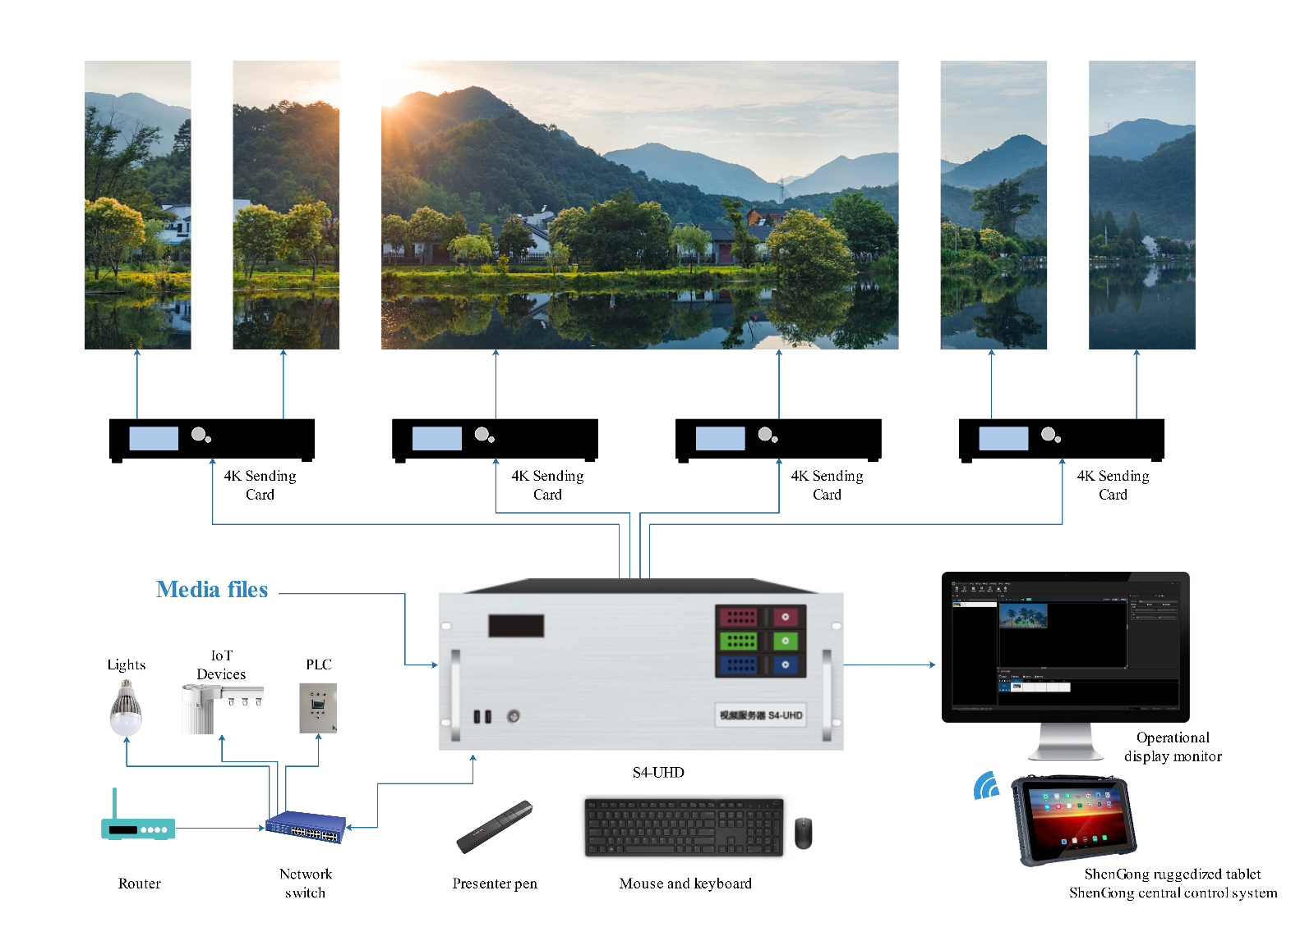
Description

When using the device, please ensure it is placed horizontally. Do not flip or vertically position the device.
This product can be installed in a standard 19-inch rack. The rack must have a weight-bearing capacity of at least four times the combined weight of all the equipment inside. Use four M5 panel screws for secure installation.

Declaration and Warning
This is a Class A product that may cause radio interference in residential environments. In such cases, users may need to take practical measures to mitigate the interference.

All rights reserved. ©2023 Shenzhen Ruizhong Technology Co., Ltd.
No part of this text document may be reproduced, copied, or distributed in any form without prior permission from our company.

Trademark Notice
is a registered trademark of Shenzhen Ruizhong Technology.

Disclaimer
We strive for accuracy and reliability in writing our documents, but we reserve the right to modify or change the content at any time without prior notice.
If you encounter any issues during use, please contact us using the contact information provided in the document, and we will do our best to provide support.

Official Website: https://www.sz-ipc.com
Address: Building 301, No.2 Shouhe Road, Jingsha Community, Kengzi Street, Pingshan District, Shenzhen, China

